

DLD Lab-12

FlipFlops



NATIONAL UNIVERSTIY OF COMPUTER AND EMERGING SCIENCES, FAST- Peshawar Campus

Department Of Computer Science

Instructor: Engr. Waseem Ullah

EL1005 – Digital Logic Design-Lab

SEMESTER SPRING 2022

Contents

1. Objectives: 2

2. Equipment Required: 2

3. Description: 2

Flip Flops 2

4. JK- FLIP FLOP 3

5. T- FLIP FLOP 4

# Objectives:

* Getting familiar with characteristic tables and characteristic functions of flip-flops
* Gaining a close insight into the functioning and properties of basic static memory circuits
* Developing skills in the composition and testing of sequential logic circuits

# Equipment Required:

* DEV-2765E Trainer Board/ Multisim 14.2 /Logic.ly
* 7486 XOR Gate IC
* 7408 AND Gate IC
* 7432 OR Gate IC
* 7404 Inverter Gate IC
* 7474 Dual +ve edge triggered D-Flip Flop
* 74112 Dual –ve edge triggered JK-Flip Flop

# Description:

# Flip Flops

A flip-flop is usually constructed by combining two same or different types of latches. Flip-flop circuits are constructed in such a way as to make them operate properly when they are a part of a sequential circuit that employs a single clock. Note that the problem with the latch is that as soon as an input changes, shortly thereafter the corresponding output changes to match it. This is what allows a change on a latch output to produce additional changes at other latch outputs while the clock pulse is at logic 1. The key to the proper operation of flip-flops is to prevent them from being transparent. In a flip-flop, before an output can change, the path from its inputs to its outputs is broken. So a flip-flop cannot “see” the change of its output or of the outputs of other, like flip-flops at its input during the same clock pulse. Thus, the new state of a flip-flop depends only on the immediately preceding state, and the flip-flops do not go through multiple changes of state. The edge triggered D flip flop avoids the problem of the RS invalid output states by not allowing the invalid states. The JK flip flop is a clocked RS flip flop with additional logic to replace the RS invalid output states with a new mode called toggle. Toggle causes the flip flop to change to the state opposite to its present state.

# JK- FLIP FLOP

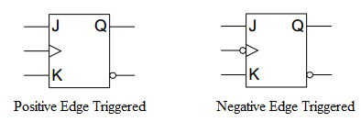

**Positive Edge Triggered JK Flip Flop**

**Circuit Diagram using D-flip Flop and basic gates**

|  |
| --- |
|  |

**Characteristic Table for JK Flip Flop:**

|  |  |  |  |  |
| --- | --- | --- | --- | --- |
| **Inputs** | | **Outputs** | | **Next State of Q** |
| J | K | Q | ~Q |  |
| 0 | 0 |  |  |  |
| 0 | 1 |  |  |  |
| 1 | 0 |  |  |  |
| 1 | 1 |  |  |  |

# T- FLIP FLOP

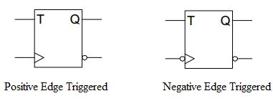

**Positive Edge Triggered T-Flip Flop**

**Circuit Diagram using D-flip Flop and basic gates**

|  |
| --- |
|  |

**Characteristic Table for T Flip Flop:**

|  |  |
| --- | --- |
| **T** | **Output** |
| 0 |  |
| 1 |  |

**Negative Edge Triggered JK Flip Flop**

***Pin Configuration of 74112 (JK-FFP):***



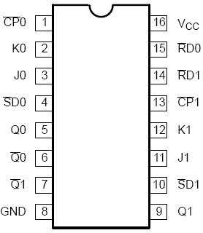

**Description of PINS:**

The 74F112, Dual Negative Edge-Triggered JK-Type Flip-Flop, feature individual J, K, Clock (CPn), Set (SD) and Reset (RD) inputs, true (Qn) and complementary (~Qn) outputs. The SD and RD inputs, when Low, set or reset the outputs as shown in the Function Table, regardless of the level at the other inputs. A High level on the clock (CPn) input enables the J and K inputs and data will be accepted. The logic levels at the J and K inputs may be allowed to change while the CPn is High and flip-flop will perform according to the Function Table as long as minimum setup and hold times are observed. Output changes are initiated by the High-to-Low transition of the CPn.

**Function Table:**

|  |  |  |  |  |  |  |  |
| --- | --- | --- | --- | --- | --- | --- | --- |
| **INPUTS** | | | | | **OUTPUTS** | | **OPERATING MODE** |
| **SD** | **RD** | **CP** | **J** | **K** | **Q** | **Q** |
| 0 | 1 | X | X | X | 1 | 0 | Asynchronous Set |
| 1 | 0 | X | X | X | 0 | 1 | Asynchronous Reset |
| 0 | 0 | X | X | X | 1* | 1* | Undetermined * |
| 1 | 1 | ↓ | 1 | 1 | ~q | q | Toggle |
| 1 | 1 | ↓ | 0 | 1 | 0 | 1 | Load “0” (Reset) |
| 1 | 1 | ↓ | 1 | 0 | 1 | 0 | Load “1” (Set) |
| 1 | 1 | ↓ | 0 | 0 | q | q | Hold “no change” |
| 1 | 1 | 1 | X | X | Q | Q | Hold “no change” |

* = Both outputs will be High while both SD and RD are Low, but the output states are unpredictable if SD and RD go High simultaneously

***Procedure***

1. Connect the trainer with the power supply
2. Mount the IC 74LS112 on the trainer board
3. Supply the VCC and GND to the pin 16 and 8 respectively
4. Connect only one of the two flip-flops available on the IC. Refer to the pin configuration and characteristic table (function table) for this IC is given above.
5. Drive the J, K and CK inputs input switch on the trainer board and CP input from the clock on the trainer board. Connect output Q0 & ~Q0 with the LED.
6. Be sure to connect the set (SD) and reset (RD) inputs to a logical 1.
7. Using the different input combinations, verify the JK flip-flop characteristic table.
8. Observe and record the output on the LED.

**Tasks:**

1. Implement JK-Flip Flop using D-flip Flop IC and basic Gates on Trainer Board and verify its truth table.
2. Modify part (a) to implement T-Flip Flop.
3. Verify JK-Flip Flop truth table using 74LS112 IC.
4. Modify part (c) to design a T-Flip Flop.